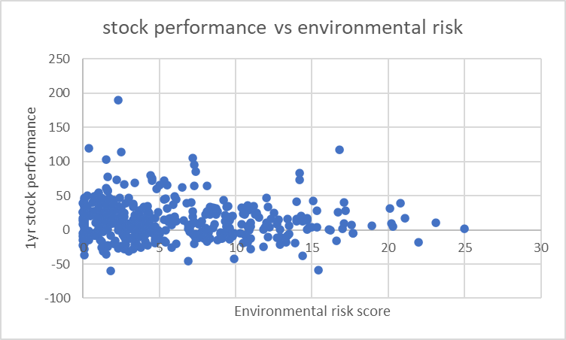

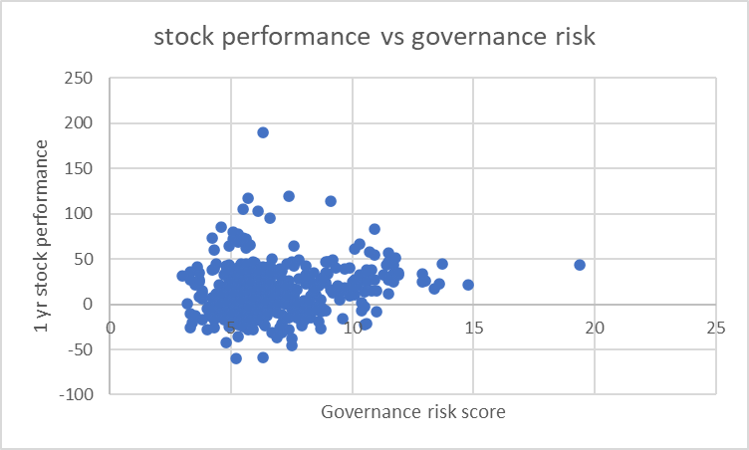

30/ 48 beat S&P 500 (0.625!) for governance score btw 10 and 20

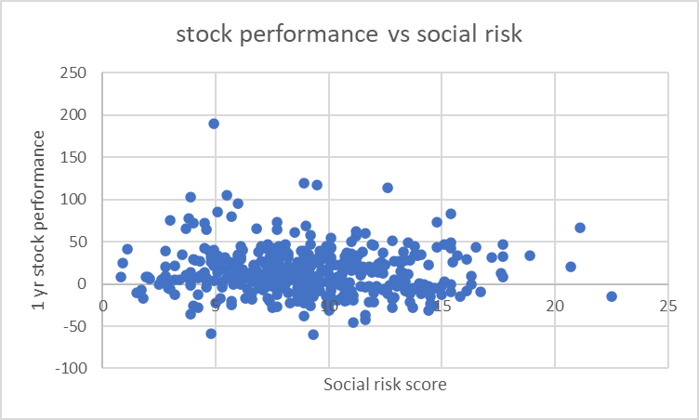

52/164 btw 10 and 25 – 0.31

13 /27 btw 15 and 25 – 0.48

64 /187 companies beat S&P 500 (ratio = 0.34)

17/50 companies beat S&P 500 (ratio = 0.34)

52/184 companies beat S&P 500 (ratio = 0.28)

133/430 companies beat S&P weighted performance ( ratio = 0.31)

